181-15-1929

Answer to the question no: 1

#include <stdio.h>

#include <string.h>

int main()

{

char str1[1000]=">Rosalind_6404";

char str2[1000]="CCTGCGGAAGATCGGCACTAGAATAGCCAGAACCGTTTCTCTGAGGCTT";

char str3[1000]=">Rosalind_5959";

char str4[1000]="CCATCGGTAGCGCATCCTTAGTCCAATTAAGTCCCTATCCAGGCGCTCC";

char str5[1000]=">Rosalind_0808";

char str6[1000]="CCACCCTCGTGGTATGGCTAGGCATTCAGGAACCGGAGAACGCTTCAGA";

char str7[1000]=">Rosalind_0809";

char str8[1000]="AGCTATAG";

char concat[1000];

printf("Length of string 1 = %d \n",strlen(str1));

printf("Length of string 2 = %d \n",strlen(str2));

printf("Length of string 3 = %d \n",strlen(str3));

printf("Length of string 4 = %d \n",strlen(str4));

printf("Length of string 5 = %d \n",strlen(str5));

printf("Length of string 6 = %d \n",strlen(str6));

printf("Length of string 7 = %d \n",strlen(str7));

printf("Length of string 8 = %d \n",strlen(str8));

strcpy(concat,str1);

strcat(concat, str2);

strcat(concat, str3);

strcat(concat, str4);

strcat(concat, str5);

strcat(concat, str6);

strcat(concat, str7);

strcat(concat, str8);

printf("Final concat string = %s \n\n",concat);

printf("Length of concat string = %d \n\n",strlen(concat));

char *word;

word=strtok(concat,">");

printf("After performing tokenization of the final concatenated string using the symbol(>): ");

while(word!=NULL)

{

printf("%s\n",word);

word=strtok( NULL,">");

}

return 0;

}

OUTPUT(NO 1)

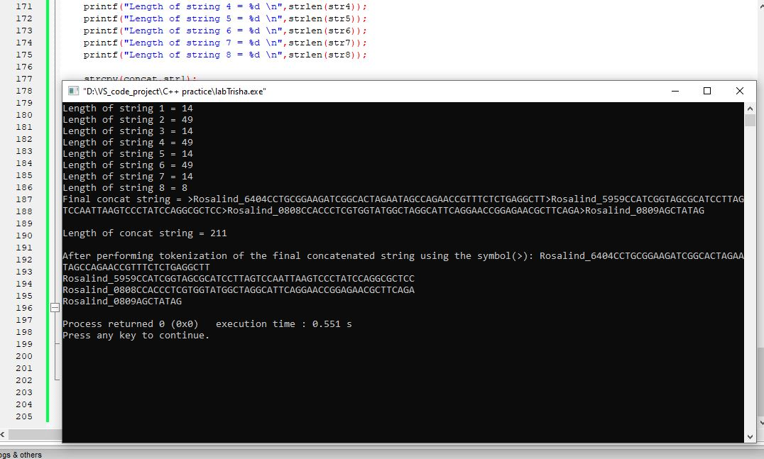

Answer to the question no: 2(a)

#include<stdio.h>

#include<string.h>

int main()

{

char s[100]="return 0";

char *word;

word=strtok(s," ;=*+/");

while(word!=NULL)

{

printf("%s\n",word);

word=strtok( NULL," ;=*+/");

}

return 0;

}

OUTPUT(NO 2(a))

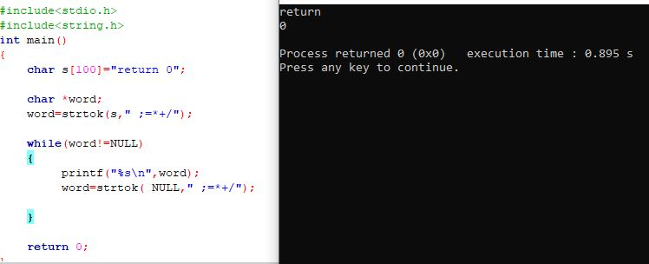

Answer to the question no: 2(b)

#include<stdio.h>

#include<string.h>

int main()

{

char s[100]="int a=b*c;";

char *word;

word=strtok(s," ;=*+/");

printf("Data type: %s\n",word);

printf("Variables are: \n");

while(word!=NULL)

{

word=strtok( NULL," ;=*+/");

printf("%s\n",word);

}

return 0;

}

OUTPUT(NO 2(b))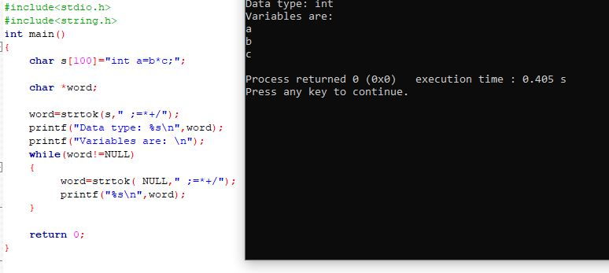

Answer to the question no: 2(c)

#include<stdio.h>

#include<string.h>

int main()

{

char s[100]="result=first+second/third";

char *word;

word=strtok(s," ;=*+/");

while(word!=NULL)

{

printf("%s\n",word);

word=strtok( NULL," ;=*+/");

}

return 0;

}

OUTPUT(NO 2(b))

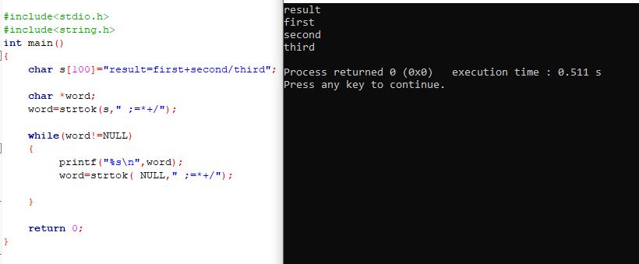

Answer to the question no: 3

#include <string.h>

#include <stdio.h>

#include <stdlib.h>

void commentFinding(char);

void lineComment();

FILE *file1, *file2;

int main()

{

char ch;

file1 = fopen("inputSanjida.txt", "r");

file2 = fopen("outputRahmanTrisha.txt", "w");

while ((ch = fgetc(file1)) != EOF)

{

commentFinding(ch);

}

fclose(file1);

fclose(file2);

printf("\n");

return 0;

}

void commentFinding(char ch)

{

char ch2;

if (ch == '#')

{

ch2 = fgetc(file1);

if (ch2 != '#')

{

lineComment();

}

else

{

fputc(ch, file2);

fputc(ch2, file2);

}

}

else

{

fputc(ch, file2);

}

}

void lineComment()

{

char e;

while ((e = fgetc(file1)) != EOF)

{

if (e == '\n')

{

return;

}

}

}

OUTPUT(NO 3)

